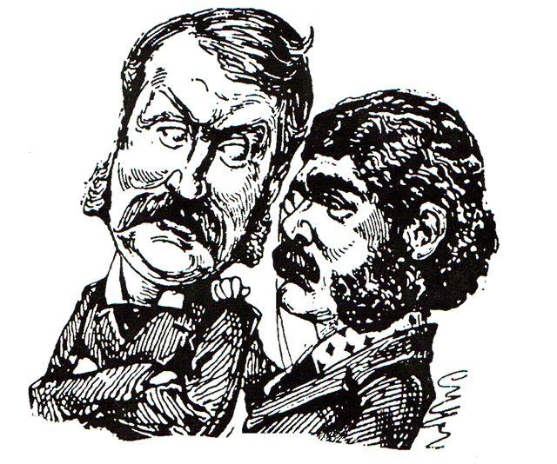

Bath Gilbert and Sullivan Society

Support Local Theatre — Become a Friend Today
Help keep Gilbert & Sullivan thriving in Bath
Membership from just £30 individual / £50 couple:
- Free ticket prize draw
- Complimentary programme
- Recognition in our programme and website
- Quarterly newsletter
- Invitations to socials and AGM

- Behind-the-scenes rehearsal access

Find out more:
- Visit: bathgands.co.uk/get-involved
- Email: bathgands@live.co.uk
- Scan the QR code:
- Complete the slip below:

✂……………………………………………………………………………………………………..………………….
Name:……………………………………………………………………………
Address:…………………………………………………………………………
Email:……………………………………………………………………………
Phone:…………………………………………………………………………...

